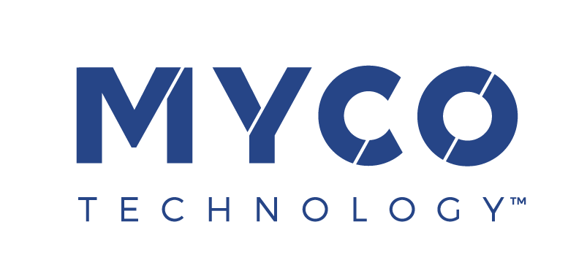

4 May 2022
PRESS RELEASE

MycoTechnology Partners with Oman Investment Authority
to Target Alternative Protein Opportunity

Oman Investment Authority (OIA) and MycoTechnology, Inc. have established a groundbreaking joint venture that will use locally-grown dates to produce high-quality mushroom-based protein. The two parties will collaborate on building a state-of-the-art production facility in Oman to scale up and commercialize this novel source of nutritious, sustainable protein. It represents the next generation of innovation driven by MycoTechnology’s proprietary fermentation platform, which harnesses mushroom mycelia to create transformative ingredients.

The strategic partnership between OIA and MycoTechnology is in line with Oman Vision 2040, which aims to attract modern technologies to the country. It links OIA’s local knowledge and public sector relationships with MycoTechnology’s cutting-edge technology. It aspires to transform the food supply landscape in the region and reflects OIA’s commitment to achieving a sustainable future by increasing local food production.

Oman is one of the world’s top 10 producers of dates, growing about 400 thousand tonnes per year. However, more than half goes to waste or animal feed. The new joint venture is expected to upcycle a significant portion of these excess dates, using the natural sugar present in the fruit as a source of carbon to fuel the production of mushroom-based protein.

Construction of the new facility is due to start in the first half of 2023 on a 10-hectare site. Commercial production is scheduled to begin by the second quarter of 2025, with up to 16,000 tonnes of dates to be processed each year. Once operational, the partners intend for the new facility to evolve into the Middle East’s leading innovation hub for food technology.

Alan Hahn, MycoTechnology CEO, commented:
“MycoTechnology is excited to be co-operating with Oman Investment Authority to build this highly innovative food oasis in the desert. It represents a breakthrough in the quest to bring food security to Oman and the wider region. This initiative will be transformative – and not just for the Middle East. We are foraging for the future, unlocking the ancient power of culinary mushrooms to feed the world’s growing population with a solution that’s been beneath our feet all along.”

Ibrahim Al Eisri, Director of Private Equity at OIA, said:
“In our international investments at OIA, we target localizing advanced modern technologies. Our partnership with Mycotechnology will deliver substantial local benefits as we pioneer the proteins of tomorrow. It will support our mission to enhance food security, diversify the Omani economy, and create well-paying jobs in an eco-friendly new sector. This joint venture will be the foundation that enables Oman to foster a new generation of talent in the sphere of food technology, here and further afield.”

Colorado-based MycoTechnology is the world’s leading explorer of mycelia – the powerful but invisible mushroom ‘root system’. OIA is a sovereign wealth fund located in Muscat, the capital of Oman. The new joint venture will operate as Vital Foods Technologies LLC.

For more information, contact:
Richard Clarke, Ingredient Communications
Tel: +44 (0)7766 256176 | Email: richard@ingredientcommunications.com

About MycoTechnology, Inc.
Established in 2013 and based in Aurora, Colorado, MycoTechnology creates products from mushroom mycelia that solve the biggest challenges in the food industry. The world’s leading explorer of mycelia, MycoTechnology is dedicated to increasing the availability of healthy, sustainable, clean label, and high-quality food options through natural mushroom fermentation. Its product portfolio includes ClearIQ™ flavor, a line of transformative mushroom-derived flavor modulation tools that decrease the perception of bitter and off-notes, enable the formulation of products with higher nutrient density, and reduce salt and sugar across a broad spectrum of applications. MycoTechnology also offers FermentIQ™ protein, a line of plant protein products produced via a proprietary fermentation process that harnesses the power of mushroom mycelia to make plant proteins that are more functional and easier to digest, and more delicious. MycoTechnology is a team of nearly 100 employee-shareholders and continues to recruit additional colleagues to aid expansion and growth.

About Oman Investment Authority (OIA)
Oman Investment Authority (OIA) is Oman’s sovereign wealth fund. It is entrusted with managing, investing, and developing the Sultanate’s national and international assets. It has diverse investment portfolios both nationally and internationally, whereby it invests in over 40 countries across various sectors including food, energy, logistics, ICT, public services, finance and investment, food security, tourism, mining, industry, and aviation.

